**Data Understanding and Visualization  
  
Summary Statistics**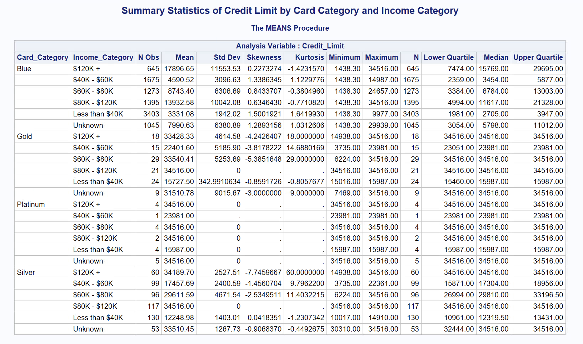

**Correlation Analysis**

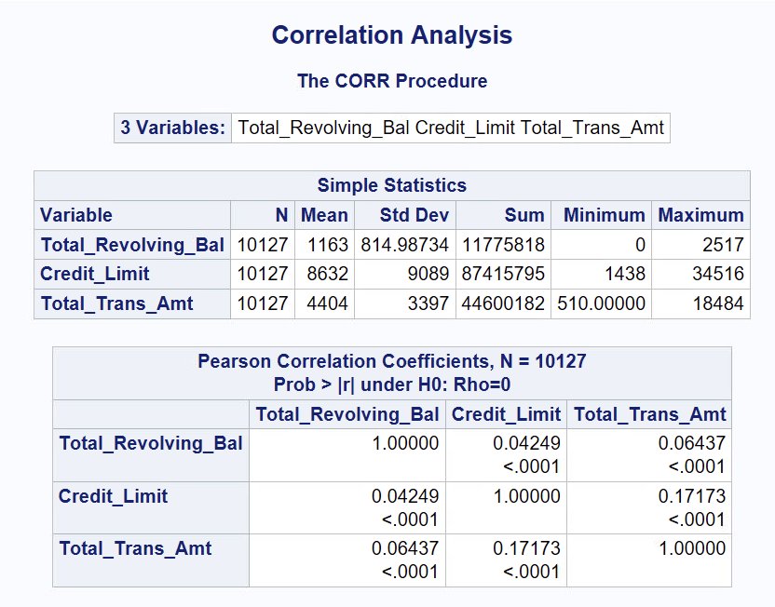

**

**Grouped Bar Charts**

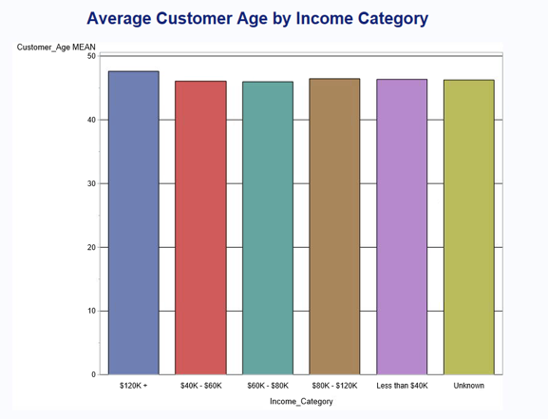

**Crosstab Analysis**

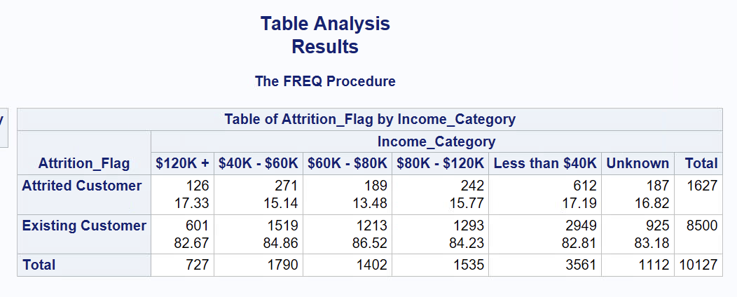

**Scatterplot with Regression Analysis**

